FITTING AN ARIMA MODEL AND FORECASTING THE NEXT FIVE VALUES

Ananya Kaushal

2022-04-26

**INTRODUCTION**

An autoregressive integrated moving average, or ARIMA, is a statistical analysis model that uses time series data to either better understand the data set or to predict future trends. A statistical model is autoregressive if it predicts future values based on past values.

**PROCEDURE**

Calling the ‘astsa’, ‘forecast’ and ‘tseries’ libraries

library(astsa)

## Warning: package 'astsa' was built under R version 4.0.5

library(forecast)

## Warning: package 'forecast' was built under R version 4.0.5

## Registered S3 method overwritten by 'quantmod':  
## method from  
## as.zoo.data.frame zoo

##   
## Attaching package: 'forecast'

## The following object is masked from 'package:astsa':  
##   
## gas

library(tseries)

## Warning: package 'tseries' was built under R version 4.0.5

Importing the dataset and plotting it as time series

data <- read.csv("p9.csv")  
  
datao = ts(data$Quakes,start = 1916,frequency = 1)  
ts.plot(datao,main="Earthquake Data")

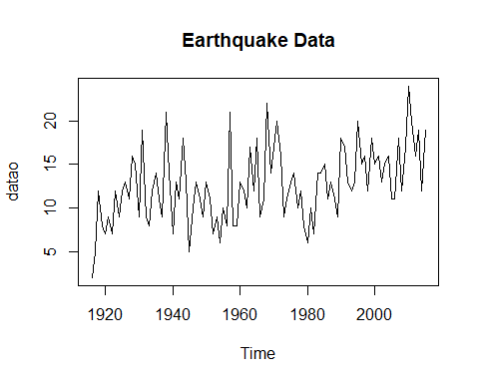

Performing the adf test

adf.test(datao)

##   
## Augmented Dickey-Fuller Test  
##   
## data: datao  
## Dickey-Fuller = -3.452, Lag order = 4, p-value = 0.04991  
## alternative hypothesis: stationary

Fitting the arima model onto the dataset

fit = auto.arima(datao, seasonal="F")  
fit

## Series: datao   
## ARIMA(0,1,1)   
##   
## Coefficients:  
## ma1  
## -0.8092  
## s.e. 0.0710  
##   
## sigma^2 = 15.53: log likelihood = -276.26  
## AIC=556.53 AICc=556.65 BIC=561.72

Plotting the ACF and PACF plots of the differentiated data to verify if the arima model is the best fit or not

acf(diff(datao))

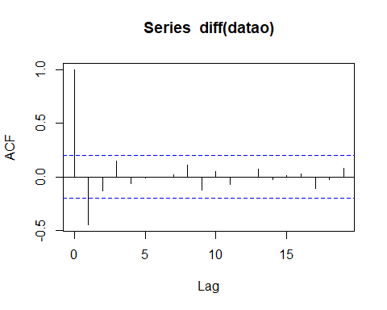

pacf(diff(datao))

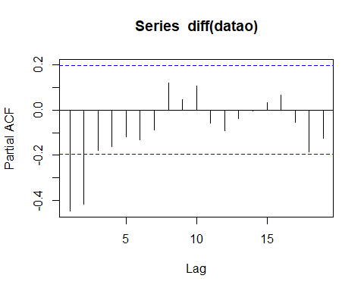

Performing residual analysis

res = resid(fit)  
acf(res)

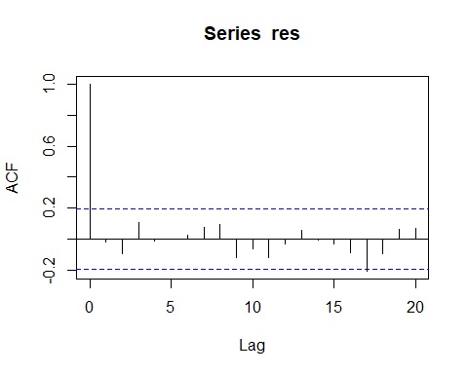

Performing Box Test to check if the residuals are uncorrelated

Box.test(res)

##   
## Box-Pierce test  
##   
## data: res  
## X-squared = 0.037841, df = 1, p-value = 0.8458

Performing Shapiro test to check for normality

shapiro.test(res)

##   
## Shapiro-Wilk normality test  
##   
## data: res  
## W = 0.98273, p-value = 0.2156

Forecasting future values and plotting them

forecast = forecast(fit, h=5)  
forecast

## Point Forecast Lo 80 Hi 80 Lo 95 Hi 95  
## 2016 16.7859 11.73592 21.83589 9.062616 24.50919  
## 2017 16.7859 11.64481 21.92700 8.923275 24.64853  
## 2018 16.7859 11.55528 22.01652 8.786360 24.78545  
## 2019 16.7859 11.46727 22.10454 8.651749 24.92006  
## 2020 16.7859 11.38068 22.19112 8.519330 25.05247

plot(forecast)

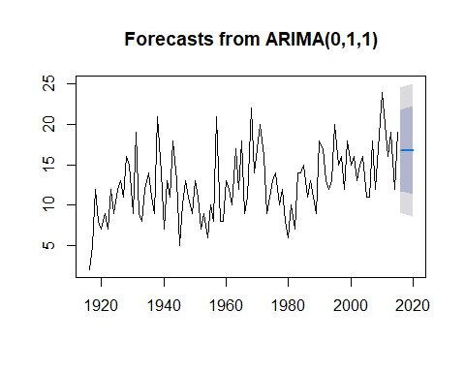

**CONCLUSION**

From the above experiment we can conclude that the best fit ARIMA model for the given dataset is ARIMA(0,1,1). Differentiating the data once also gives us the same result. Forecasting the future five values shows us that they follow a stagnant trend.